**Task: Setting up AWS CloudWatch to monitor EC2 Instance.**

Here will setup the CloudWatch Dashboard for EC2 Instance’s (CPU, Memory, Disk metrics), for that we need to install AWS Cloud Agent using Perl script & SSM.

Step 1: Create an AWS EC2 IAM Role and add CloudWatch and SSM Full Access. - Role Name: EC2-CloudWatch-Role. \

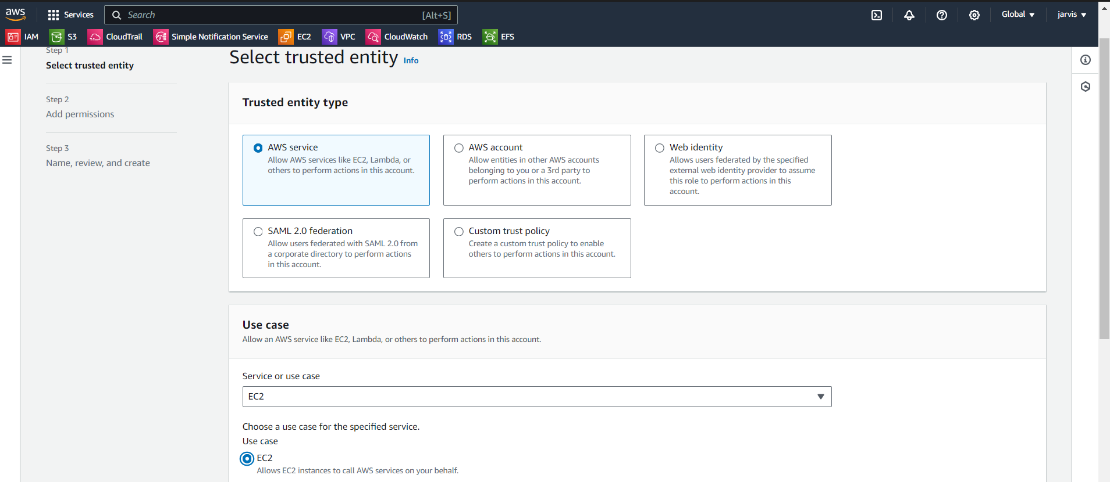

Permission: CloudWatch and SSM Full Access

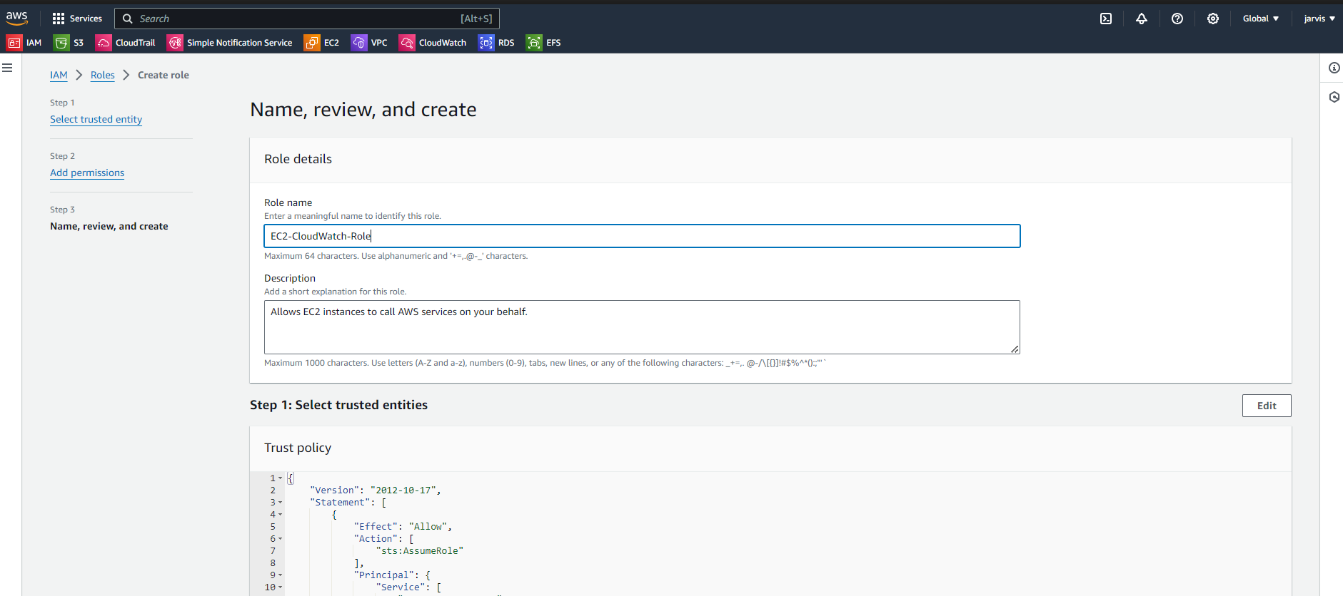

Step 2: Create a Parameter in Systems Manager with the name "/alarm/AWS-CWAgentLinConfig" and store the value. \

Here in AWS System manager, we can store our required parameters, for wow we need to create an separate parameter.

Mention the type (string) and its value,

The required parameter has been stored successfully in AWS System Manager.

**## Value for the SSM Parameter (/alarm/AWS-CWAgentLinConfig):**

```bash

{

"metrics": {

"append_dimensions": {

"InstanceId": "${aws:InstanceId}"

},

"metrics_collected": {

"mem": {

"measurement": [

"mem_used_percent"

],

"metrics_collection_interval": 60

},

"disk": {

"measurement": [

"disk_used_percent"

],

"metrics_collection_interval": 60

}

}

}

}

```

Step 3: Create an EC2 Instance, Attach the role created in Step 1 and Add the script in userdata for agent.

While creating the instance we can attach the role.

We can add role into existing server as well….

Add userdata to installing the agent

#!/bin/bash

wget https://s3.amazonaws.com/amazoncloudwatch-agent/linux/amd64/latest/AmazonCloudWatchAgent.zip

sudo apt install unzip -y

unzip AmazonCloudWatchAgent.zip

sudo ./install.sh

sudo /opt/aws/amazon-cloudwatch-agent/bin/amazon-cloudwatch-agent-ctl -a fetch-config -m ec2 -c ssm:/alarm/AWS-CWAgentLinConfig -s

Server into the running state...

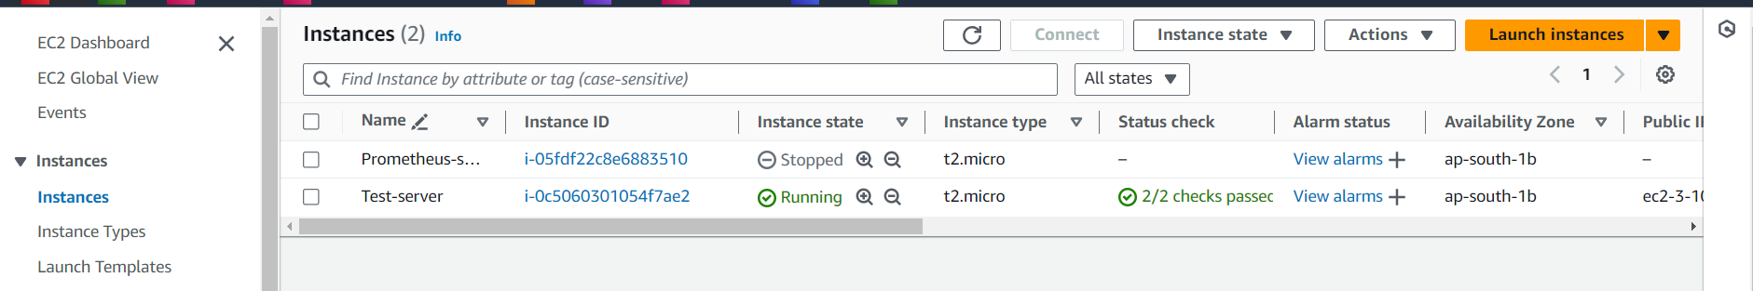

Step4: Check if EC2 Instance has CWAgent Installed or not to running below commands

# sudo /opt/aws/amazon-cloudwatch-agent/bin/amazon-cloudwatch-agent-ctl -m ec2 -a status

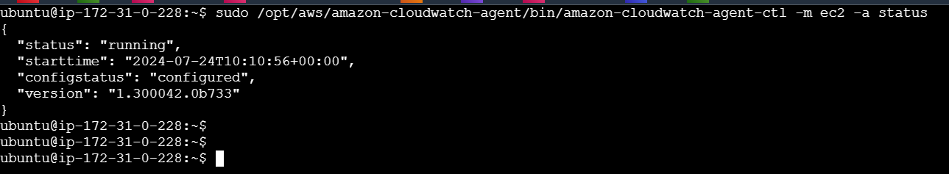

Here we can se ec2 instance cloudwatch agent is up & running…

Step 4: Check memory & disk utilization is working or not in CloudWatch? It pushes the metrics from CloudWatch, instance-id will take metadata from instance.

Here we can see the custom metrics collected in CWAgent

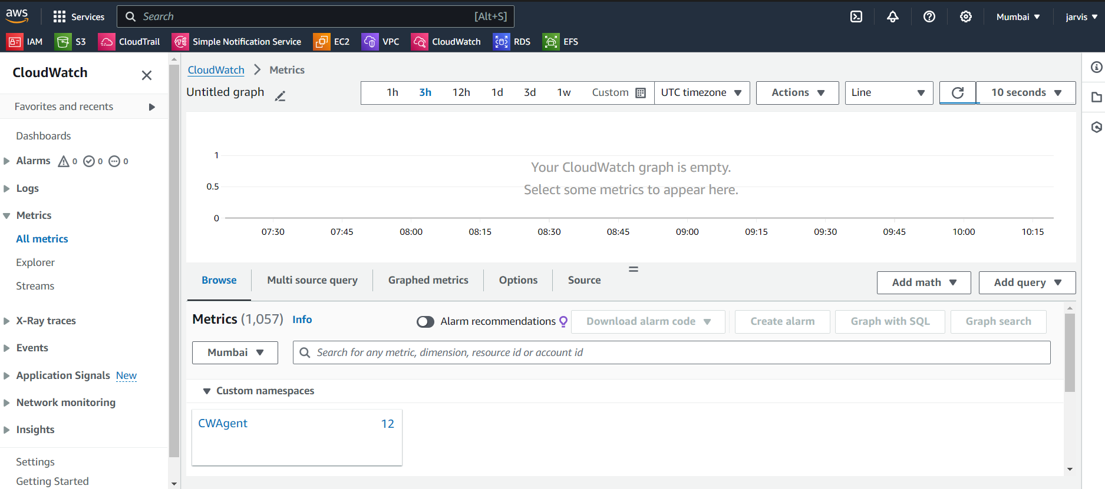

In below screenshot we can see two section:

InstanceId, device, fstype, path = gives memory utilization percentage

InstanceId = gives cpu utilization percentage

Disk Usage: /

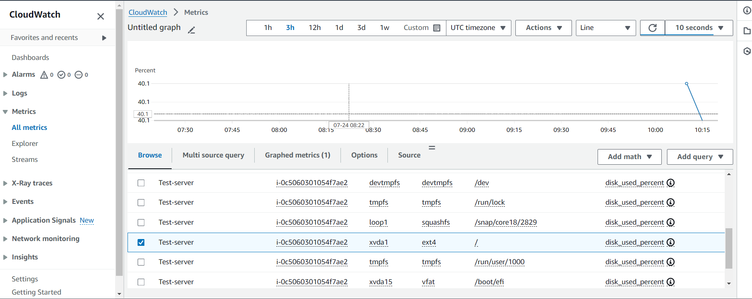

Memory Usage:

Step5: Create a Dashboard for ec2 which contains the (cpu, memory, disk)

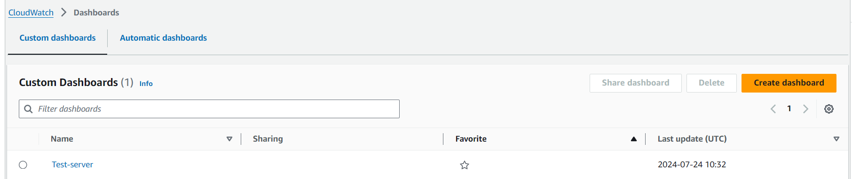

Add Metrics:

Select all three metrics: CPU – from default, memory & disk – from CWAgent

Memory utilization metric:

Final Dashboard for test-server:

